HW 14-TK-Hillel-BA IT-ENG-SRS v 1.3

1) Create a Google document with a template for specifying requirements for a software product, choose the description language for yourself, the main thing is that everything is consistent

2) Integrate the requirements from [Homework 1](https://docs.google.com/document/d/1KXxzfrFBbJpbb3--z0rDibQBqzkDxEO0NSB5Dt5Ybgg/edit?usp=sharing) into the created template

3) Make a list of questions arisen while familiarizing yourself with the template *(see the end of doc)*

4) Add a link(s) to the Google document(s) demonstrating the template for the requirements and questions *(see the end of doc* or [this link](https://docs.google.com/document/d/1Q4D-p8agUYv62VAKTQxKVwP4drKb9MDEFH1jw_Cs8d4/edit?usp=sharing))

**\*For reader:** untouched template is marked with colored text (at least, in Google Document)

**Software Requirements**

**Specification**

**for**

**Raiffeisen Online (Mobile App)**

**Version 0.3 (in progress)**

**Prepared by Taras Khamardiuk**

**BA Group, Hillel IT School**

**2021-05-24**

**Table of Contents**

Table of Contents........................................................................................................................... ii

Revision History............................................................................................................................. ii

1. Introduction............................................................................................................................. 1

1.1 Purpose................................................................................................................................. 1

1.2 Document Conventions.......................................................................................................... 1

1.3 Intended Audience and Reading Suggestions........................................................................... 1

1.4 Product Scope........................................................................................................................ 1

1.5 References............................................................................................................................. 1

2. Overall Description................................................................................................................. 2

2.1 Product Perspective................................................................................................................ 2

2.2 Product Functions.................................................................................................................. 2

2.3 User Classes and Characteristics............................................................................................. 2

2.4 Operating Environment.......................................................................................................... 2

2.5 Design and Implementation Constraints................................................................................... 2

2.6 User Documentation............................................................................................................... 2

2.7 Assumptions and Dependencies.............................................................................................. 3

3. External Interface Requirements........................................................................................... 3

3.1 User Interfaces....................................................................................................................... 3

3.2 Hardware Interfaces............................................................................................................... 3

3.3 Software Interfaces................................................................................................................. 3

3.4 Communications Interfaces..................................................................................................... 3

4. System Features....................................................................................................................... 4

4.1 System Feature 1.................................................................................................................... 4

4.2 System Feature 2 (and so on).................................................................................................. 4

5. Other Nonfunctional Requirements...................................................................................... 4

5.1 Performance Requirements..................................................................................................... 4

5.2 Safety Requirements.............................................................................................................. 5

5.3 Security Requirements............................................................................................................ 5

5.4 Software Quality Attributes.................................................................................................... 5

5.5 Business Rules....................................................................................................................... 5

6. Other Requirements................................................................................................................ 5

Appendix A: Glossary................................................................................................................... 5

Appendix B: Analysis Models...................................................................................................... 5

Appendix C: To Be Determined List........................................................................................... 6

**Revision History**

| **Name** | **Date** | **Reason For Changes** | **Version** |
| --- | --- | --- | --- |
| First Draft | 2021-05-21 | Initial training version for study purposes to be checked by lecturer | Version 0.1 |
| Second Draft (amended) | 2021-05-24 | Initial training version for study purposes to be checked by lecturer | Version 0.2 |
| Third Draft (amended) | 2021-07-15 | Amended training version for study purposes to be checked by lecturer | Version 0.3 |

# **1.** **Introduction**

## **1.1** **Purpose**

<Identify the product whose software requirements are specified in this document, including the revision or release number. Describe the scope of the product that is covered by this SRS, particularly if this SRS describes only part of the system or a single subsystem.>

## **1.2** **Document Conventions**

<Describe any standards or typographical conventions that were followed when writing this SRS, such as fonts or highlighting that have special significance. For example, state whether priorities for higher-level requirements are assumed to be inherited by detailed requirements, or whether every requirement statement is to have its own priority.>

## **1.3** **Intended Audience and Reading Suggestions**

<Describe the different types of reader that the document is intended for, such as developers, project managers, marketing staff, users, testers, and documentation writers. Describe what the rest of this SRS contains and how it is organized. Suggest a sequence for reading the document, beginning with the overview sections and proceeding through the sections that are most pertinent to each reader type.>

## **1.4** **Product Scope**

<Provide a short description of the software being specified and its purpose, including relevant benefits, objectives, and goals. Relate the software to corporate goals or business strategies. If a separate vision and scope document is available, refer to it rather than duplicating its contents here.>

## **1.5** **References**

<List any other documents or Web addresses to which this SRS refers. These may include user interface style guides, contracts, standards, system requirements specifications, use case documents, or a vision and scope document. Provide enough information so that the reader could access a copy of each reference, including title, author, version number, date, and source or location.>

# **2.** **Overall Description**

## **2.1** **Product Perspective**

<Describe the context and origin of the product being specified in this SRS. For example, state whether this product is a follow-on member of a product family, a replacement for certain existing systems, or a new, self-contained product. If the SRS defines a component of a larger system, relate the requirements of the larger system to the functionality of this software and identify interfaces between the two. A simple diagram that shows the major components of the overall system, subsystem interconnections, and external interfaces can be helpful.>

## **2.2** **Product Functions**

< Summarize the major functions the product must perform or must let the user perform. Details will be provided in Section 3, so only a high-level summary (such as a bullet list) is needed here. Organize the functions to make them understandable to any reader of the SRS. A picture of the major groups of related requirements and how they relate, such as a top-level data flow diagram or object class diagram, is often effective.>

**2.2 User Requirements (User Stories)**

* As a bank customer, I want to be able to access my accounts online from my smartphone in order to save time on calling and/or going to the bank.
* As a user of the application, I want to be able to enter the application using a biometric scanner so not to enter a username and password every time I use the application.
* As a bank customer, I want to be able to transfer funds via a smartphone so not to waste time going to the bank or using third-party resources (sites or terminals of payment systems).
* As a bank customer, I want to be able to find out the current exchange rates right in the application so not to waste time looking for similar information on other resources.
* As a user of the application, I want to be able to open deposit accounts in national currency directly in my smartphone, without visiting the bank, in order to save time.

## **2.3** **User Classes and Characteristics**

<Identify the various user classes that you anticipate will use this product. User classes may be differentiated based on frequency of use, subset of product functions used, technical expertise, security or privilege levels, educational level, or experience. Describe the pertinent characteristics of each user class. Certain requirements may pertain only to certain user classes. Distinguish the most important user classes for this product from those who are less important to satisfy.>

## **2.4** **Operating Environment**

<Describe the environment in which the software will operate, including the hardware platform, operating system and versions, and any other software components or applications with which it must peacefully coexist.>

## **2.5** **Design and Implementation Constraints**

<Describe any items or issues that will limit the options available to the developers. These might include: corporate or regulatory policies; hardware limitations (timing requirements, memory requirements); interfaces to other applications; specific technologies, tools, and databases to be used; parallel operations; language requirements; communications protocols; security considerations; design conventions or programming standards (for example, if the customer’s organization will be responsible for maintaining the delivered software).>

## **2.6** **User Documentation**

<List the user documentation components (such as user manuals, on-line help, and tutorials) that will be delivered along with the software. Identify any known user documentation delivery formats or standards.>

## **2.7** **Assumptions and Dependencies**

<List any assumed factors (as opposed to known facts) that could affect the requirements stated in the SRS. These could include third-party or commercial components that you plan to use, issues around the development or operating environment, or constraints. The project could be affected if these assumptions are incorrect, are not shared, or change. Also identify any dependencies the project has on external factors, such as software components that you intend to reuse from another project, unless they are already documented elsewhere (for example, in the vision and scope document or the project plan).>

# **3.** **External Interface Requirements**

## **3.1** **User Interfaces**

<Describe the logical characteristics of each interface between the software product and the users. This may include sample screen images, any GUI standards or product family style guides that are to be followed, screen layout constraints, standard buttons and functions (e.g., help) that will appear on every screen, keyboard shortcuts, error message display standards, and so on. Define the software components for which a user interface is needed. Details of the user interface design should be documented in a separate user interface specification.>

Below, the user interface prototypes are provided.

Sketch_1.1 (scan)

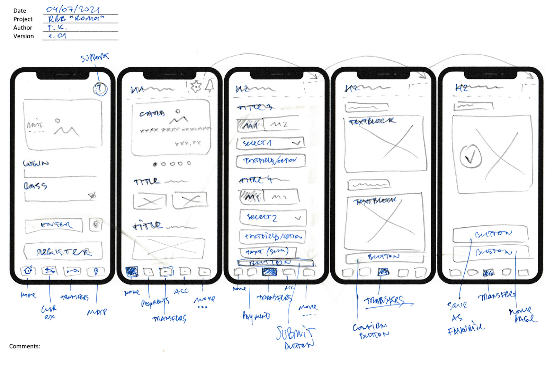

[Sketch_1.2](https://miro.com/welcomeonboard/UVozM1JoNGlLU253UlhBbk12Z3NWblBOaThwNVpnRTBCb1AyZGhQSGFDMDM3azQySnQ1SXdReWN5UVBIMFRkbHwzMDc0NDU3MzU1MzA5NDE5MTEw) (screen shot)

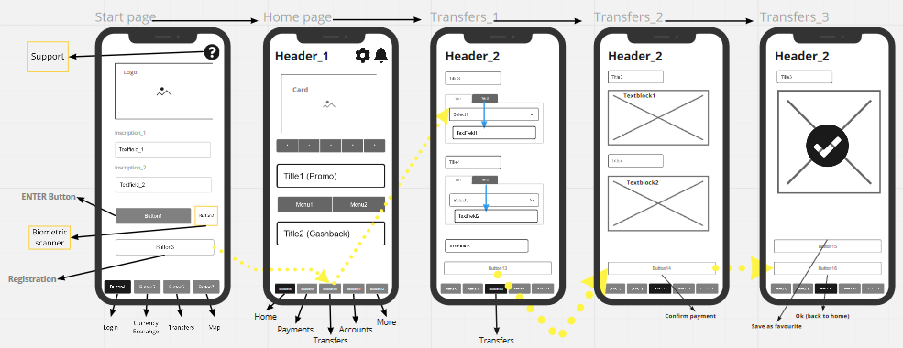

[Wireframe](https://miro.com/welcomeonboard/UVozM1JoNGlLU253UlhBbk12Z3NWblBOaThwNVpnRTBCb1AyZGhQSGFDMDM3azQySnQ1SXdReWN5UVBIMFRkbHwzMDc0NDU3MzU1MzA5NDE5MTEw) (screen shot)

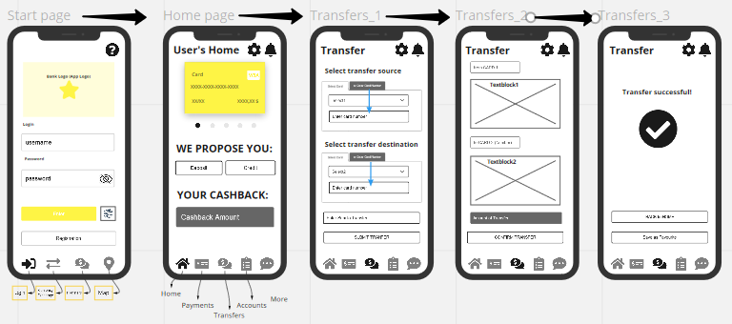

Mock-up (screen shot)

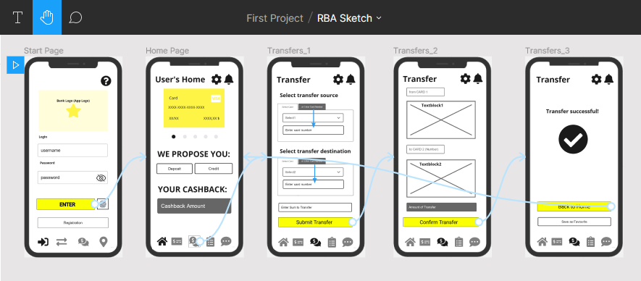

Mock-up (clickable prototype)

<https://www.figma.com/proto/nQudwzp58t3mAKlbY4Zs9K/RBA-Sketch?node-id=210%3A40&scaling=scale-down&page-id=0%3A1>

## **3.2** **Hardware Interfaces**

<Describe the logical and physical characteristics of each interface between the software product and the hardware components of the system. This may include the supported device types, the nature of the data and control interactions between the software and the hardware, and communication protocols to be used.>

## **3.3** **Software Interfaces**

<Describe the connections between this product and other specific software components (name and version), including databases, operating systems, tools, libraries, and integrated commercial components. Identify the data items or messages coming into the system and going out and describe the purpose of each. Describe the services needed and the nature of communications. Refer to documents that describe detailed application programming interface protocols. Identify data that will be shared across software components. If the data sharing mechanism must be implemented in a specific way (for example, use of a global data area in a multitasking operating system), specify this as an implementation constraint.>

## **3.4** **Communications Interfaces**

<Describe the requirements associated with any communications functions required by this product, including e-mail, web browser, network server communications protocols, electronic forms, and so on. Define any pertinent message formatting. Identify any communication standards that will be used, such as FTP or HTTP. Specify any communication security or encryption issues, data transfer rates, and synchronization mechanisms.>

# **4.** **System Features**

<This template illustrates organizing the functional requirements for the product by system features, the major services provided by the product. You may prefer to organize this section by use case, mode of operation, user class, object class, functional hierarchy, or combinations of these, whatever makes the most logical sense for your product.>

**4.1** **User Story 1 (US_1) Initial Login Procedure**

As a user of the application, I want to be able to enter the application using my credentials and a secure password.

4.1.1 Description and Priority

A user shall be able to get authorized access by entering the personal login and password for using the mobile banking application.

The priority is set as High. The feature shall be included in MVP.

<Provide a short description of the feature and indicate whether it is of High, Medium, or Low priority. You could also include specific priority component ratings, such as benefit, penalty, cost, and risk (each rated on a relative scale from a low of 1 to a high of 9).>

4.1.2 Stimulus/Response Sequences

<List the sequences of user actions and system responses that stimulate the behavior defined for this feature. These will correspond to the dialog elements associated with use cases.>

4.1.3 Functional Requirements 1 (FR_1)

FR_1.1: Log in to the application with a password.

**4.2** **User Story 2 (US_2) Auxiliary Login Procedures**

As a user of the application, I want to be able to enter the application using a biometric scanner so not to enter a username and password every time I use the application.

4.2.1 Description and Priority

A user shall be able to authorize him/herself into the application by using the auxiliary methods of authorization as biometric scanners, depending on the phone model (TBD).

The priority is set as Medium. The feature shall be included in version 2+.

4.2.2 Stimulus/Response Sequences

<List the sequences of user actions and system responses that stimulate the behavior defined for this feature. These will correspond to the dialog elements associated with use cases.>

4.2.3 Functional Requirements 2 (FR_2)

FR_2.1: Log in to the application through a biometric fingerprint scanner to authorize in the application

## **4.3** **User Story 3 (US_3) Account Operations within the App**

As a bank customer, I want to be able to access my accounts online from my smartphone in order to save time on calling and/or going to the bank

<Don’t really say “System Feature 1.” State the feature name in just a few words.>

4.3.1 Description and Priority

A user shall be able to use the mobile banking application with the functionality of the “bank in the phone”, namely have access to and control over his/her accounts using the specific application installed in the smartphone and being authorized for such access.

The priority is set as High. The feature shall be included in MVP.

<Provide a short description of the feature and indicate whether it is of High, Medium, or Low priority. You could also include specific priority component ratings, such as benefit, penalty, cost, and risk (each rated on a relative scale from a low of 1 to a high of 9).>

4.3.2 Stimulus/Response Sequences

<List the sequences of user actions and system responses that stimulate the behavior defined for this feature. These will correspond to the dialog elements associated with use cases.>

4.3.3 Functional Requirements 3 (FR_3)

FR_3.1: Get access to the functionality of the Application via the respective Login Procedure.

FR_3.2: Show the history of the user’s transactions in the selected time interval (day, week, month, etc.)

**4.4** **User Story 4 (US_4) Account Operations within the App**

As a bank customer, I want to be able to transfer funds between my accounts, cards, and third-party accounts and cards online from my smartphone in order to save time on calling and/or going to the bank for performing of such actions.

4.4.1 Description and Priority

A user shall be able to use the mobile banking application with the functionality of the “bank in the phone”, namely have to be able to transfer funds between his accounts and cards as well as to send the funds to third-party accounts and cards using the application installed in the smartphone and being authorized for such transactions.

The priority is set as High. The feature shall be included in MVP.

4.4.2 Stimulus/Response Sequences

<List the sequences of user actions and system responses that stimulate the behavior defined for this feature. These will correspond to the dialog elements associated with use cases.>

4.4.3 Functional Requirements 4 (FR_4)

FR_4.1: Proceed money transfers between user’s accounts.

FR_4.2: Make transfers to Raiffeisen accounts.

FR_4.3: Make transfers to Raiffeisen cards.

FR_4.4: Transfer funds to accounts of other banks.

FR_4.5: Transfer funds to cards of other banks.

**4.5** **User Story 5 (US_5) Useful Information**

As a bank customer, I want to be able to find out the current exchange rates right in the application, so not to waste time looking for similar information on other resources.

4.5.1 Description and Priority

A user shall be able to familiarize him/herself with the actual exchange rates right in the Application (TBD).

The priority is set as Medium. The feature shall be included in MVP.

4.5.2 Stimulus/Response Sequences

<List the sequences of user actions and system responses that stimulate the behavior defined for this feature. These will correspond to the dialog elements associated with use cases.>

4.5.3 Functional Requirements 5 (FR_5)

FR_5.1: Provide current up-to-date exchange rates.

**4.6** **User Story 6 (US_6) Opening the new accounts**

As a user of the application, I want to be able to open deposit accounts in national currency directly in my smartphone, without visiting the bank, in order to save time.

4.6.1 Description and Priority

A user shall be able to open him/herself an account for payments, deposit, or credit line within the Application (TBD).

The priority is set as Medium. The feature shall be included in Version 2+.

4.6.2 Stimulus/Response Sequences

<List the sequences of user actions and system responses that stimulate the behavior defined for this feature. These will correspond to the dialog elements associated with use cases.>

4.6.3 Functional Requirements 6 (FR_6)

FR_6.1: Open an account for payments in national or foreign currency.

**4.7** **User Story 7 (**[**US_7**](https://jira.ithillel.com/browse/ONBA1305-95)**) Transfer between user's accounts**

As a bank customer, I want to be able to transfer funds between my accounts, so to be able to manage them directly in the application.

4.7.1 Description and Priority

After successful authorization, a user shall select 'money transfer' so to be able to perform operations with funds available on accounts owned by transferring the money between accounts owned. The procedure shall provide the account 'from' together with account 'to', a sum of transfer to be inserted (typed manually) by the user, and 'submit' UI element. A user shall verify the transfer by an available verification mechanism so to finalize the transfer between accounts owned.

The priority is set as Medium. The feature shall be included in MVP.

4.7.2 Stimulus/Response Sequences

<List the sequences of user actions and system responses that stimulate the behavior defined for this feature. These will correspond to the dialog elements associated with use cases.>

4.7.3 Functional Requirements 7 (FR_7)

FR_7.1: Transfer funds between user’s accounts.

**4.8** **User Story 8 (**[**US_8**](https://jira.ithillel.com/browse/ONBA1305-96)**) Transfer between user's cards**

As a bank customer, I want to be able to transfer funds between my cards, so to be able to manage them directly in the application.

4.8.1 Description and Priority

After successful authorization, a user shall select 'money transfer' so to be able to perform operations with funds available on cards owned by transferring the money between cards owned. The procedure shall provide the card account 'from' together with card account 'to', sum of transfer to be inserted (typed manually) by the user and 'submit' UI element. A user shall verify the transfer by an available verification mechanism so to finalize the transfer between card accounts owned.

The priority is set as Medium. The feature shall be included in MVP.

4.8.2 Stimulus/Response Sequences

<List the sequences of user actions and system responses that stimulate the behavior defined for this feature. These will correspond to the dialog elements associated with use cases.>

4.8.3 Functional Requirements 8 (FR_8)

FR_8.1: Transfer funds between user’s cards.

**4.9** **User Story 9 (**[**US_9**](https://jira.ithillel.com/browse/ONBA1305-98)**) Transfer between user's account and a third-party account**

As a bank customer, I want to be able to transfer funds between my account and a third-party account, so to be able to make transfers directly in the application.

4.9.1 Description and Priority

After successful authorization, a user shall select 'money transfer' so to be able to perform operations with funds available on accounts owned by transferring the money from it to the third-party accounts. The procedure shall provide the selection of the account 'from' together with account 'to', the sum of transfer to be inserted (typed manually) by the user, the 'to' account number to be inserted by the user, and 'submit' UI element. A user shall verify the transfer by an available verification mechanism so to finalize the transfer between accounts owned.

The priority is set as Medium. The feature shall be included in MVP.

4.9.2 Stimulus/Response Sequences

<List the sequences of user actions and system responses that stimulate the behavior defined for this feature. These will correspond to the dialog elements associated with use cases.>

4.9.3 Functional Requirements 9 (FR_9)

FR_9.1: Transfer funds between the user’s account and a third-party account.

**4.10 User Story 10 (**[**US_10**](https://jira.ithillel.com/browse/ONBA1305-99)**) Transfer between user's card and a third-party card**

As a bank customer, I want to be able to transfer funds between my card account and a third-party card account, so to be able to make transfers directly in the application.

4.10.1 Description and Priority

After successful authorization, a user shall select 'money transfer' so to be able to perform operations with funds available on card accounts owned by transferring the money from it to the third-party card accounts. The procedure shall provide the selection of the card account 'from' together with card account 'to', the sum of transfer to be inserted (typed manually) by the user, the 'to' card number to be inserted by the user, and 'submit' UI element. A user shall verify the transfer by an available verification mechanism so to finalize the transfer between accounts owned.

The priority is set as Medium. The feature shall be included in MVP.

4.10.2 Stimulus/Response Sequences

<List the sequences of user actions and system responses that stimulate the behavior defined for this feature. These will correspond to the dialog elements associated with use cases.>

4.10.3 Functional Requirements 10 (FR_10)

FR_10.1: Transfer funds between the user’s account and a third-party card.

REQ-1:

REQ-2:

## **4.2** **System Feature 2 (and so on)**

# **5.** **Other Nonfunctional Requirements**

## **5.1** **Performance Requirements**

<If there are performance requirements for the product under various circumstances, state them here and explain their rationale, to help the developers understand the intent and make suitable design choices. Specify the timing relationships for real-time systems. Make such requirements as specific as possible. You may need to state performance requirements for individual functional requirements or features.>

**5.1 Non-functional Requirements**

* Use the application 24/7.
* The application (system) must check the correctness of the payment via SMS verification within 10 seconds after the user sends the transaction data
* The system should upload and display the records of the last transactions within 5 seconds.
* The system must notify the user of a successful transaction via SMS notification within 30 seconds after the completion of the transaction.
* The system must notify the user about the payments planned by the user through a push notification indicating the name and contents of the transaction 5 minutes before the scheduled time of the transaction.

## **5.2** **Safety Requirements**

<Specify those requirements that are concerned with possible loss, damage, or harm that could result from the use of the product. Define any safeguards or actions that must be taken, as well as actions that must be prevented. Refer to any external policies or regulations that state safety issues that affect the product’s design or use. Define any safety certifications that must be satisfied.>

## **5.3** **Security Requirements**

<Specify any requirements regarding security or privacy issues surrounding use of the product or protection of the data used or created by the product. Define any user identity authentication requirements. Refer to any external policies or regulations containing security issues that affect the product. Define any security or privacy certifications that must be satisfied.>

## **5.4** **Software Quality Attributes**

<Specify any additional quality characteristics for the product that will be important to either the customers or the developers. Some to consider are: adaptability, availability, correctness, flexibility, interoperability, maintainability, portability, reliability, reusability, robustness, testability, and usability. Write these to be specific, quantitative, and verifiable when possible. At the least, clarify the relative preferences for various attributes, such as ease of use over ease of learning.>

## **5.5** **Business Rules**

<List any operating principles about the product, such as which individuals or roles can perform which functions under specific circumstances. These are not functional requirements in themselves, but they may imply certain functional requirements to enforce the rules.>

# **6.** **Other Requirements**

<Define any other requirements not covered elsewhere in the SRS. This might include database requirements, internationalization requirements, legal requirements, reuse objectives for the project, and so on. Add any new sections that are pertinent to the project.>

Appendix A: Glossary

The Glossary is available at: <https://confluence.ithillel.com/x/mh4l>

<Define all the terms necessary to properly interpret the SRS, including acronyms and abbreviations. You may wish to build a separate glossary that spans multiple projects or the entire organization, and just include terms specific to a single project in each SRS.>

Appendix B: Analysis Models

<Optionally, include any pertinent analysis models, such as data flow diagrams, class diagrams, state-transition diagrams, or entity-relationship diagrams.>

Appendix C: To Be Determined List

<Collect a numbered list of the TBD (to be determined) references that remain in the SRS so they can be tracked to closure.>

[Epic](https://jira.ithillel.com/browse/ONBA1305-94) Operations with user's account(s)

* account-to-account transfers (rules - TBD),
* account-to-card transfers (rules - TBD).
* card-to-card transfers (rules - TBD),
* additional combinations and options (TBD).

User Story 7 [(US_7](https://jira.ithillel.com/browse/ONBA1305-95)) Transfer between user's accounts,

* the allocation and style of 'submit' UI element - TBD
* the verification mechanism for money transfers - TBD

User Story 8 ([US_8](https://jira.ithillel.com/browse/ONBA1305-96)) Transfer between user's cards

* the allocation and style of 'submit' UI element - TBD
* the verification mechanism for money transfers - TBD

User Story 9 ([US_9](https://jira.ithillel.com/browse/ONBA1305-98)) Transfer between user's account and a third-party account

* the allocation and style of 'submit' UI element - TBD
* the verification mechanism for money transfers - TBD
* commission message - TBD

Acceptance Criteria

* right-side account details shall include the account number in the respective format (TBD)

User Story 10 ([US_10](https://jira.ithillel.com/browse/ONBA1305-99)) Transfer between user's card and a third-party card

* the allocation and style of 'submit' UI element - TBD
* the verification mechanism for money transfers - TBD
* commission message - TBD

Acceptance Criteria

* right-side account details shall include the card number in the respective format (TBD)

<https://docs.google.com/document/d/1Q4D-p8agUYv62VAKTQxKVwP4drKb9MDEFH1jw_Cs8d4/edit?usp=sharing>

**Question List:**

1. How long does it normally take to fill in such a complicated and detailed document in a small, medium, and big project perspective?
2. What are the timeframes normally for having this document ready in a small, medium, and big project?
3. What is the normal algorithm for filling in such a document?
4. Why there are no clear ‘user stories’ section and where to put them?
5. Will I ever be able to make such a document on my own correctly?
6. How to fill in the paragraphs with information that I have no access to in this particular case?
7. Having lack of technical knowledge, who shall be consulted for clarifying such specific information?